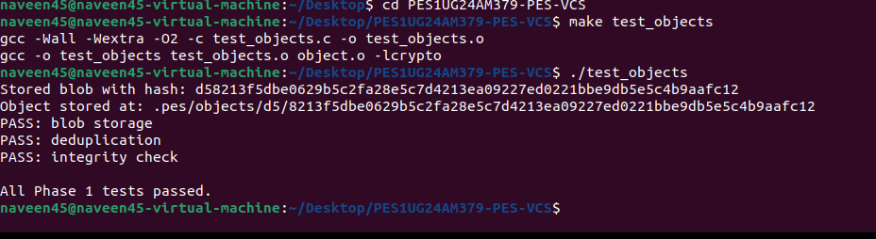
1B
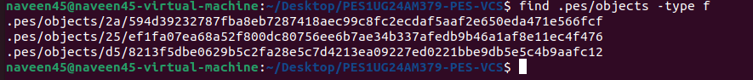
2A
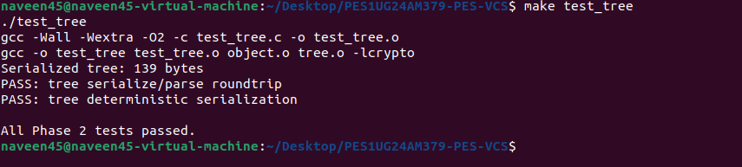
2B

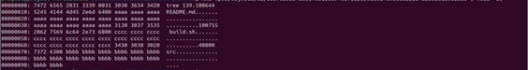

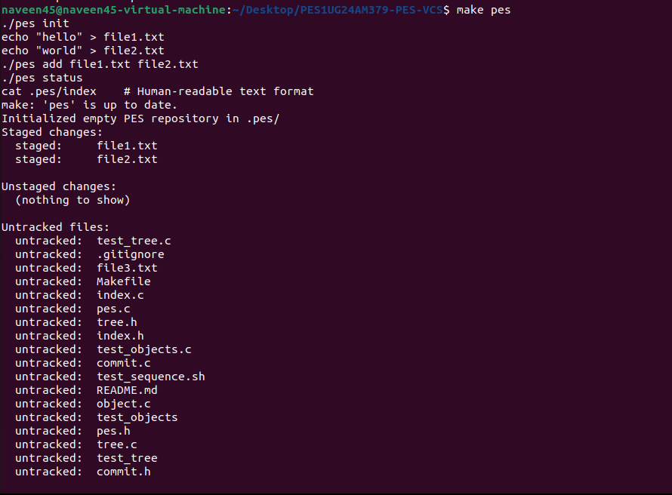
3B
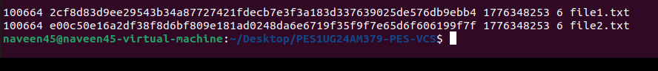

4A
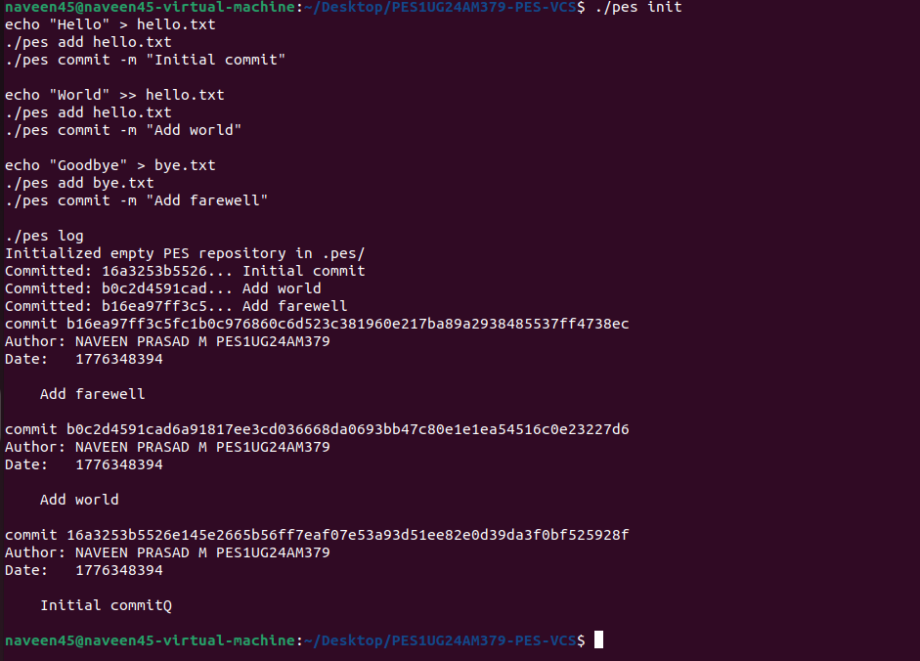
4B
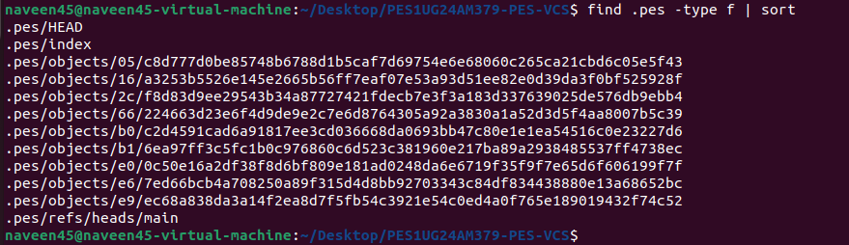

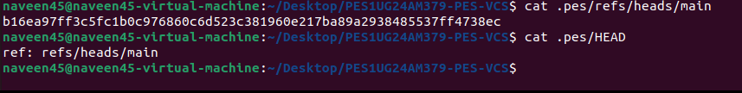

Q5.1: Implementing pes checkout <branch>
To implement a checkout, the system must bridge the gap between the internal object store and the physical files you see in your folder.
- Internal Changes: The .pes/HEAD file must be updated to point to the new branch path (e.g., ref: refs/heads/<branch>).
- Working Directory Changes: The system must perform a "three-way" sync. It looks at the Tree object of the target branch and:
  - Creates/Overwrites files that exist in the target branch.
  - Deletes files that exist in the current directory but are absent in the target branch.
- The Complexity: The operation must be atomic. If the power cuts out while you are halfway through overwriting main.c, your project is corrupted. Real Git handles this by updating the index first and using temporary files to ensure it can roll back if the operation fails.

Q5.2: Detecting a "Dirty" Working Directory
A "dirty" directory contains work that hasn't been saved to a commit. To detect this conflict without re-hashing every single file (which is slow), you use the Index as a cache:
- Stat Check: Compare the current file’s size and modification time (mtime) on disk to the metadata stored in the Index. If they differ, the file is modified.
- Comparison: If the file is modified, you check if that specific file is different in the

Target Branch's Tree.
- The Rule: If the file in your folder is different from your current commit, and it’s also different in the branch you want to move to, the checkout must fail to prevent your unsaved work from being overwritten.

Q5.3: Detached HEAD
  - The State: "Detached HEAD" occurs when .pes/HEAD contains a raw ObjectID (hash) instead of a reference to a branch file.

  - What happens: You can still commit! The new commit will point to the previous hash as its parent. However, since no branch (like main) is updated to point to these new commits, they are not part of any "timeline."
  - Recovery: If you checkout another branch, you lose the hash of the work you just did. To recover, you would use the reflog (a hidden log of every hash HEAD has ever held) or manually create a branch at that hash: pes branch new-feature <lost-hash>.

Phase 6: Garbage Collection (GC) Q6.1: The Mark-and-Sweep Algorithm
Object stores are "append-only," meaning they grow forever. To reclaim space, Git uses a
Mark-and-Sweep algorithm:
- Mark: Start at the "Roots" (every hash inside refs/heads/*, refs/tags/*, and HEAD). Follow every link: Commits → Trees → Subtrees → Blobs. Every hash reached is marked as "reachable."
- Sweep: Scan the .pes/objects directory. Any file whose hash was not marked is considered "orphaned" and is deleted.
  - Data Structure: A Hash Set (or a highly optimized Bitset) is used to track reachable hashes efficiently.
  - Estimation: For 100,000 commits and 50 branches, you might visit roughly 300,000 to 1,000,000 objects, depending on how much history is shared between branches.

Q6.2: Concurrent GC Race Conditions
  - The Danger: GC and Commits both touch the object store. A race condition occurs when GC deletes an object that is currently being created.
  - The Scenario: 1. User runs pes add. A new Blob is written to .pes/objects. 2. GC starts. It sees this new Blob, but because the user hasn't run pes commit yet, nothing "points" to it. 3. GC deletes the Blob as "unreachable." 4. User runs pes commit. The commit fails because its intended content was just deleted.
  - The Solution: Git uses a grace period (the prune timer, usually 2 weeks). GC will never delete an object that has a "last modified" timestamp newer than the threshold, giving the user plenty of time to finish their commit.

